**Hackathon Project Name** - Find travel insurance plan for students

**Cohart Code** – QEA058QE21

**Coach Name** – Naveen Kumar

**Group ID** – 07

**Group Member Name** – **POC** :- 1)Prafull Jadhav (2108102)

2)Abhishek Gouraj (2108441)

3)Sunny Bhosale (21080303)

4)Supriya Shinde (2108437)

5)Ritik Sharma (2108405)

**OS Use** – Windows 10

**Browser** – Chrome/Firefox

**Driver Use** – Chrome Driver & Gecko Driver

**Jar File** – Selenium Jar File

#### **FrameWork Use** – Keyword Driven Framework

**Xml File Name** – Pom.Xml File & TestNG.xml

**Dependencies Use** – POM

**Test Case** – All the Test scenarios that has been mentioned in the platform has been runed in TestNG format.

* Travel Insurance : Student Insurance Plans has been Displayed Sucessfully into the console
* Car Insurance : Error has been found & screenshot has been captured successfully.
* Health Insurance : Health Insurance Menu List is obtained

**Problem Statement : Find travel insurance plan for students**

1. display three lowest international  travel insurance plan with amount and insurance provider company
2. Group of  2 student people (Age 22,21)
3. For any European country  
   (Suggested Site: policybazaar however you are free to use any other legitimate site)

**Detailed Description: Hackathon Ideas**

1. Find travel insurance plan for students, for 2 people (Age 22 & 21) & any European country, fill further dummy details & display three lowest international  travel insurance plan with amount and insurance provider company
2. Get a Car Insurance quote, proceed without  car number, keep filling details, give invalid email or phone number & capture the error message
3. Retrieve all Health Insurance menu items and store in a List; Display the same  
   (Suggested Site: policybazaar.com however you are free to use any other legitimate site)

**Key Automation Scope**

* Handling alerts, search option
* Validation of date controls
* Filling simple form, Capture warning message
* Extract menu items & store in collections
* Navigating back to home page

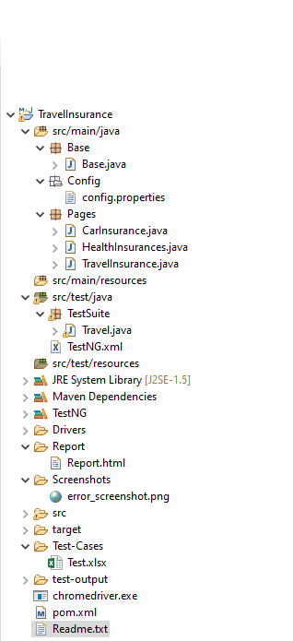**Project Framework:**

**Steps to execute the script inside framework:**

**Step-1:**

Open pom.xml , check the required dependencies and refresh the entire project.

**Stpe-2:**

Identify the main script to execute from below path:

 Run using TestNg.xml (By Right clicking on the run option & choose TestNG Test.

Below is the console report attached:

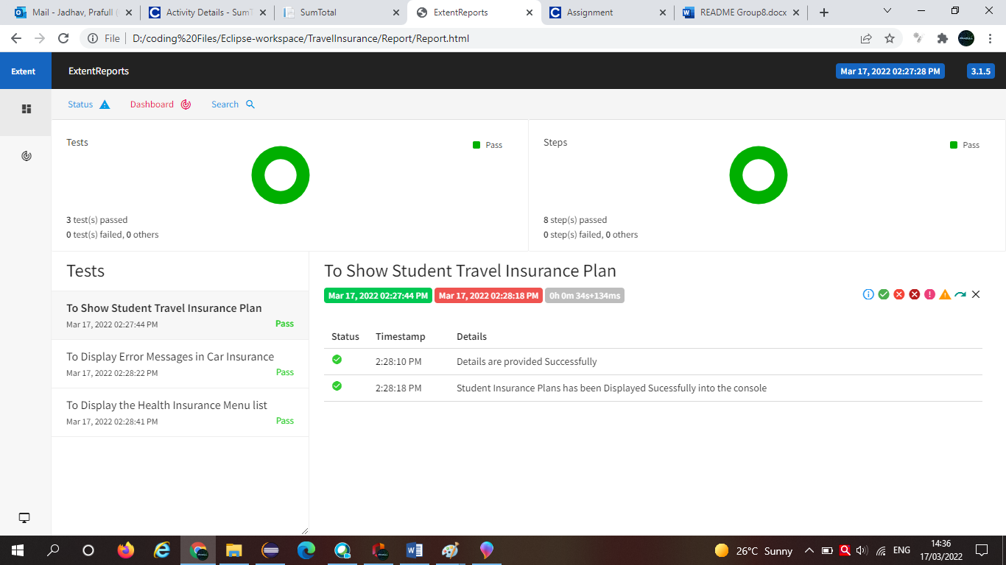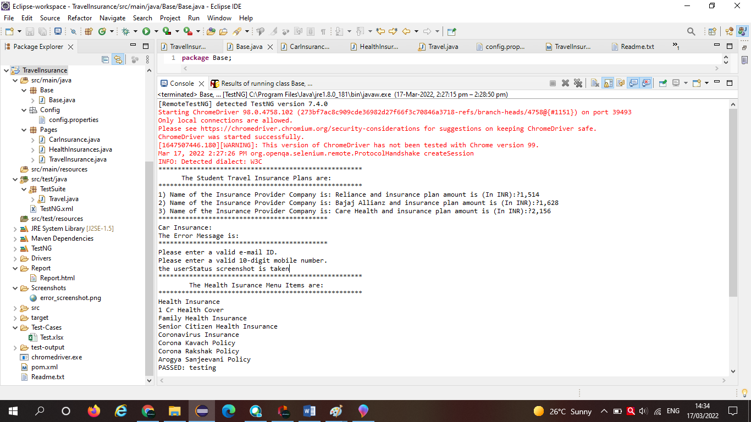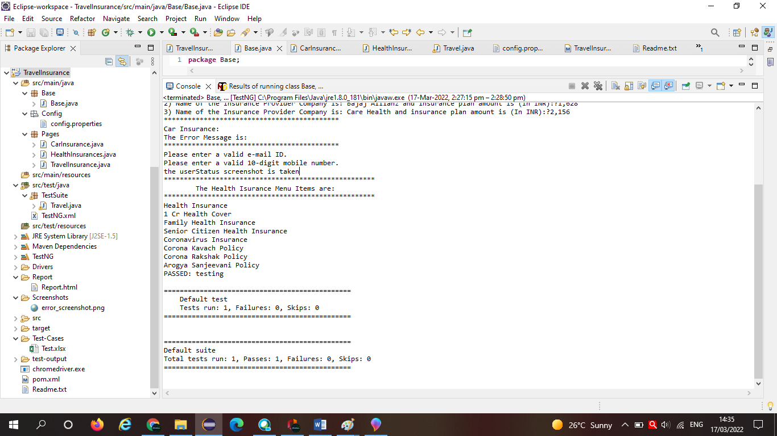

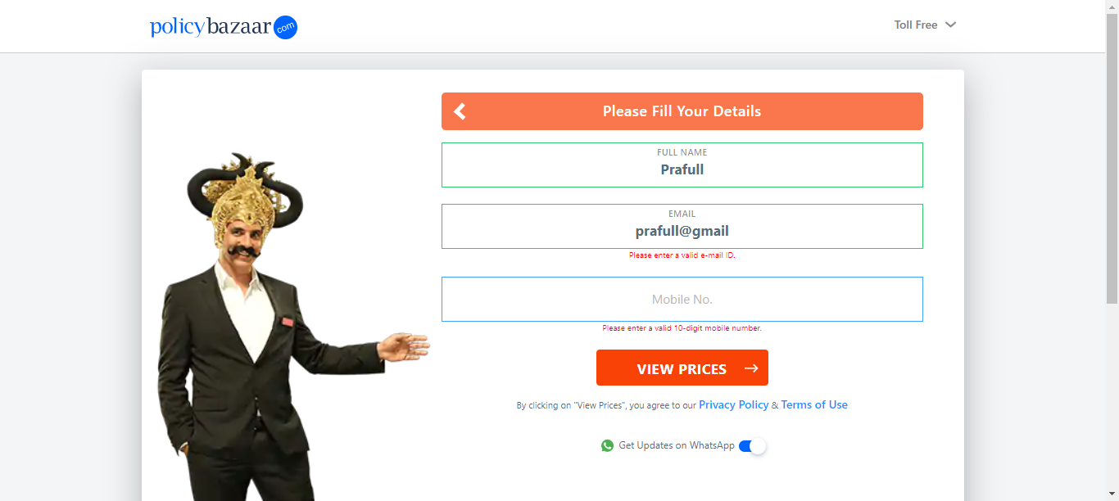

Error screenshot captured ( Car Insurance).